**Mini Project Report on**



**TITLE**



**Submitted in partial fulfilment of the requirement for the award of the degree of**

**BACHELOR OF TECHNOLOGY**

**IN**

**COMPUTER SCIENCE & ENGINEERING**

**Submitted by:**

**Student Name : Sujal Aswal** **University Roll No. 2019160**

***Under the Mentorship of***

**Mr Ashwini Kumar**

**Assistant Professor**



**Department of Computer Science and Engineering**

**Graphic Era (Deemed to be University)**

**Dehradun, Uttarakhand**

**July-2023**



**CANDIDATE’S DECLARATION**

I hereby certify that the work which is being presented in the project report entitled **“Face Emotion Detection”** in partial fulfillment of the requirements for the award of the Degree of Bachelor of Technology in Computer Science and Engineeringof the Graphic Era (Deemed to be University), Dehradun shall be carried out by the under the mentorship of **Mr Ashwini Kumar, Assistant Professor**

, Department of Computer Science and Engineering, Graphic Era (Deemed to be University), Dehradun.

Name :   Sujal Aswal University Roll no : 2019160

**Table of Contents**

|  |  |  |
| --- | --- | --- |
| **Chapter No.** | **Description** | **Page No.** |
| Chapter 1 | Introduction |  |
| Chapter 2 | Literature Survey |  |
| Chapter 3 | Methodology |  |
| Chapter 4 | Result and Discussion |  |
| Chapter 5 | Conclusion and Future Work |  |
|  | References |  |

**Chapter 1**

**Introduction**

**Facial** **recognition,** also known as **facial** **recognition,** is a technology **designed** to **recognize** and interpret human emotions from facial expressions using **facial** **recognition** and machine **learning.** The human face is a **powerful** source of **emotion,** and this technology **bridges** **the** **gap** **between** **humans** **and** **computers** **by** **enabling** machines to understand and respond to human **emotions.** **The**  
**face** **detection** process **has** several steps:  
1. Face **detection:** The first step is to **identify** and **recognize** human faces in **a** **photo** or **video.** This is **usually** **done** using algorithms **such** **as** Haar **incremental** or deep **learning** **based** **on** **facial** **recognition.**  
2. **Face** **Analysis:** **After** **detecting** the **face,** the next step is to identify **important** facial **features** such as the position of the eyes, **nose** and mouth. These **important** **characters** **are** points **used** for further analysis.  
3. Feature Extraction: **Extract** **features** **from** **facial** **markings** such as facial **expressions.**  
Commonly used features include the **alignment** of **the** facial muscles, **the** shape of the mouth, and **the** movement of the eyebrows.  
4. **Sensitivity** Classification: Machine learning **algorithms** such as deep neural **networks** are **used** to classify extracted features **based** **on** specific **sentiments.** **Observed** emotions include happiness, sadness, anger, surprise, fear, and disgust.  
5.  
Real-time **analysis:** Face **analysis** can be used in **applications** **in** **real** **time,** **allowing** **the** **device** or **system** to respond appropriately **from** the **point** **of** **view.** For **example,** it **can** be **used** **to** **create** human-computer interaction, virtual reality, or personalized experiences.  
Face **recognition** **applications** are diverse and **effective:**  
• Human-Computer Interaction: **Virtual** **assistants** can **improve** **the** user **experience** **by** **changing** **the** **response** **to** **the** **user's** **emotions** in **many** **applications** such as video **games** and smart **devices.**  
• Market Research: Companies can use **market** research **techniques** to **measure** **customers'** **response** to products, **promotions** or services.  
• **Medical:** **Neuroimaging** **aids** in mental health **diagnosis** and **monitoring** **by** helping **doctors** assess **a** **patient's** **mental** **state.**  
• **Learning** **Skills:** **Learning** tools can **include** **self-discovery** **of** learning **needs** and **providing** feedback tailored to **student** responses.  
• Security: **Can** **be** **used** **in** security and **surveillance** **to** **identify** potential threats or **misconduct** in public **places.**  
However, the ethical implications of such **technology** **should** **be** **considered** as it **relates** **to** the processing of sensitive personal **information.** Privacy concerns and potential biases in the **process** **must** be carefully addressed to ensure responsible and fair use of **face** **masks.**  
  
**"2018** is the year **of** **machine** **learning** to **understand** human **behavior"** **-** **Andrew** Moore, **head** of computer science at Carnegie **Mellon** **University.**  
**Today,** **with** the **spread** of **technology,** our desires **are** **increasing** **endlessly.** **Currently,** **many** research **projects** **are** going **into** digital **imaging** and image processing. The way **forward** **is** exponential and **calculative.** **Photography** is a **very** **big** **science** in **today's** world and its applications are very **wide.** Image processing is the **study** of **signals** where both input and output are images.  
One of the most important **applications** of **image** processing is **face** recognition. Our **emotions** **are** **expressed** **through** our face. Facial **expressions** **play** an important role in interpersonal communication. Facial expression is a **nonverbal** **expression** expressed in **the** face **according** **to** our emotions. Automatic recognition of facial **expressions** plays an important role in artificial intelligence and robotics and is **therefore** **the** need of **this** generation.  
Some related **applications** include **authentication** and **access** control, **video** **telephony** and **teleconferencing,** **forensics** **applications,** **human-computer** **interactions,** **automated** **surveillance,** **cosmetics,** and **more.** The **aim** of this project is to develop **an** **automatic** **face** **recognition** **system** **that** can **use** and recognize **images** **of** **human** **faces** **with** **a** **specific** **expression** and **divide** **them** into seven different **language** **groups,** such **as:** I. Neutral II. **Anger** III. Disgust IV.  
Fear V. **Joy** VI. **Fear** VII. **surprised.** **A** **lot** **of** **work** **has** been done in this **area** and our goal **is** not only to **create** **automatic** **face** **recognition,** but also **to** **improve** the accuracy of this system compared to other **existing** systems.

**Chapter 2**

**Literature Survey**

**Facial** **recognition** has been **an** **important** area of **​​computer** vision and machine learning. Here are some key research papers that contributed to the **study:**  
  
"Facial **Expression** **Recognition:** A **Survey"** by S. L. Happy and A. Routray (International Journal of Computer Applications, 2015)  
This **article** provides **a** **comprehensive** **review** of **the** **various** techniques and **methods** used in

**face** **learning,** including **face** **recognition** and **methods.**  
S. **Zafeiriou** et al. (International Journal of Computer Vision, 2017)  
This **article** discusses the challenges and **strategies** **of** **face** recognition in **unrestricted** real-world **scenarios** **covering** **various** modalities such as audio and video.  
  
"Deep **Convolutional** **Neural** **Networks** **in** **Emotion** **Recognition** **of** **Facial** **Expressions:** A **Comprehensive** **Review",** S. Sharma **et** **al.**  
S. Bhatia **(Neural** **Computing,** 2019)  
This review **article** **presents** the **application** of deep convolutional neural networks (CNNs) **for** **face** recognition and provides **insight** into various **neural** **networks,** **absorption** and **information** used for **work.**  
  
**"Facial** **Expression** **Recognition** **Research** for **Human-Computer** **Interactions",** P. **Sagonas** et al. (Image and **Visual** Computing, 2016)  
**This** **research** **focuses** on the **use** of **visual** **aids** in **human-computer** **interaction** **and** discusses **problems** and potential applications in this **field.**  
"Local binary **models** and **their** application to facial image analysis: **a** **review",** T. **Ojala** et al. (IEEE Transactions on Pattern Analysis and Machine Intelligence, 2002)  
**Although** **this** **article** **does** not **focus** on emotion recognition, **it** introduces Local Binary Patterns (LBP), a widely used **descriptive** **model** in facial analysis.  
  
**"Representational** **Learning** for **Face** **Recognition:** A **Practical** **Review",** Y. **Zhang** et al.  
**(Neural** **Computing,** 2018)  
This review covers various representation **techniques** **for** **face** **analysis,** including **artificial** **intelligence** and deep **learning.**  
  
"Affectiva-MIT Facial Expression Dataset (AM-FED): **Natural** and Spontaneous Facial Expressions Collected **in** **the** **'Wild'",** M. **Koelstra** et al. (IEEE Transactions on Affective Computing, 2020)  
This **article** presents the Affectiva-MIT Facial Expression Dataset (AM-FED), a large dataset containing facial expressions in **a** **real** **environment.**  
  
These are just a few examples, the field of **facial** **recognition** is **constantly** **changing** with new research and **development.**  
If you **want** to **do** **new** research, I **suggest** **you** search **using** **keywords** **in** academic databases **such** **as** Google Scholar, IEEE Xplore, **PubMed.**

**Chapter 3**

**Methodology**

**Image:** **Facial** Emotion Detection System  
**An** **image** or video containing one or more human faces.  
Face Detection: **The**  
  
**uses** face detection **techniques** **such** **as** Haar **Cascades,** Single Shot Multibox Detector - **SSD** or You Only **See** **One** - **YOLO** to detect and **identify** faces in input **images** or **snapshots.**

* **Face** **Bookmark** Detection:  
    
  For each detected face, **use** **face** landmark detection **(eg.**  
  **For** **example,** dlib, **MTCNN** or deep learning **model** to **detect** **important** facial **features** such as eyes, **nose** and **mouth).**
* Feature Extraction:  
    
  **Extracts** features from facial landmarks to represent **the** **face.** **Features** include:  
  **The** **distance** between **the** corners **of** **the** **eyes** and **the** **corners** **of** **the** **mouth.**  
  **Lashes.**  
  **Mouth** **width** and **height.**  
  **Eyes** **(eg,** **open,** closed).  
  **Strength** of facial muscles **(eg.**  
  **For** **example.** **raise** **your** eyebrows, **smile).**
* Emotion Classification:  
    
  **uses** machine learning **models** **such** **as** Support Vector **Machines** - SVM, Convolutional Neural **Networks** - **CNN** or Recurrent Neural **Networks** - **RNN** to classify **certain** features **according** **to** **certain** **emotions.**  
  **Normal** emotions include happiness, sadness, anger, surprise, fear, and disgust.
* Output:  
    
  For each **facial** **appearance,** the system **assigns** **an** **emotional** **tag** **and** a confidence score **indicating** the **accuracy** of the prediction.
* **Live** Analysis:  
   The system can be designed to perform real-time **facial** **analysis** in **a** video **stream** or live **camera.**  
   **The** **desired** **result** can be displayed **on** **the** **screen** or used to trigger **a** **custom** **function** in **the** **dialog.**  
    
    
    
  **3.1 Algorithm:**
* Step **1:** **Collect** **an** **image** **dataset.** (In this **example,** we **use** **the** FER2013 **database,** **which**

**Contains** 35887 **precropped** **48** **×** **48** **pixel** grayscale **images,** each labeled with one of 7 **emotional** **categories:** **angry,** **disgusted,** **scared,** **happy,** **sad,** **surprised,** and neutral. **44**

Step **2:** **Convert** **faces** **to** grayscale images.  
Step **5:** The pipeline ensures **that** **each** image can be fed **to** the input **process** (1, 48, 48) **as** **a**  
numpy array.  
  
Step **3:** **The** numpy array **is** passed **to** the Convolution2D layer.  
Step **6:** **Convolution** **to** **create** **the** **map.** **Chapter**

**Step** **4** **of  
:** **The** **pooling** **method** **named** **MaxPooling2D** **uses** **windows** **in** **the** **map** **specification** **(2,** **2)** **and** **stores** **only** **the** **highest** **pixel** **values.**  
  
Step **5:** **During** **training,** the **neural** **network** **performs** **forward** **and** **backward** **propagation** **of** pixel **values** **​​  
.**  
Step **6:** **The** Softmax function **represents** itself as **the** **result** **of** each **class** **hypothesis.**  
  
The model **can** show **detailed** **probabilistic** composition of **facial** **expressions.**  
  
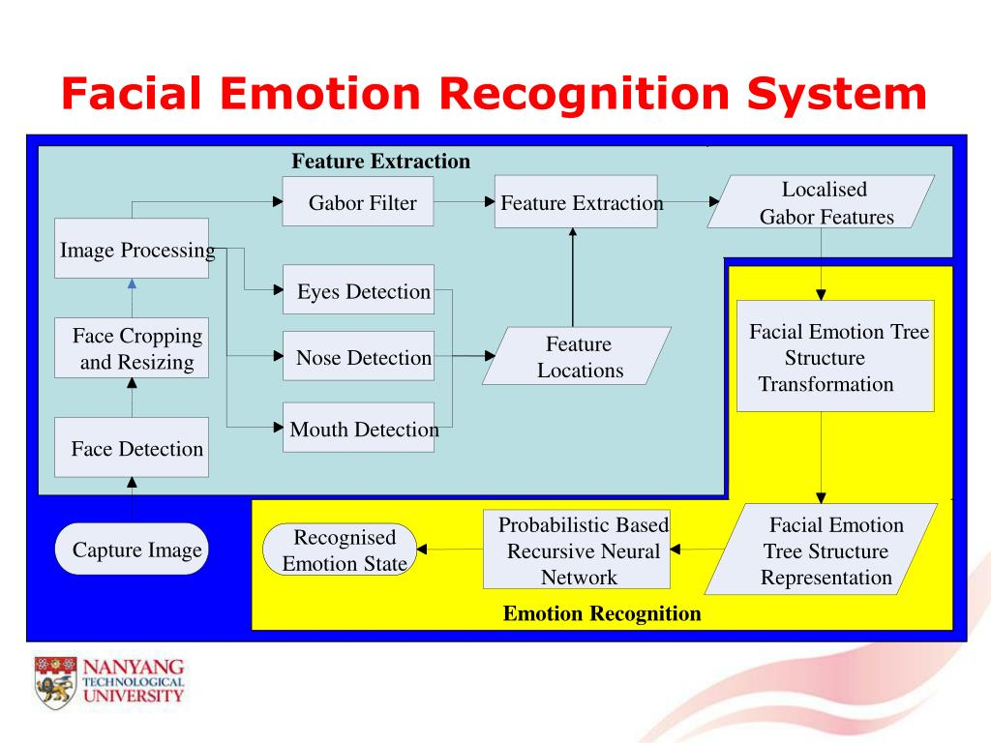

**Chapter 4**

**Result and Discussion**

**Measuring** **accuracy** and **performance:**  
  
Researchers **often** **use** **indicators** **such** **as** accuracy, precision, recall, **F1** **score,** and confusion **matrix** **to** **evaluate** **face** **recognition** **performance.**  
Accuracy measures the overall **accuracy** of **the** **hypothesis.**  
Precision **represents** the **ratio** of **the** correctly predicted **hypothesis** **to** **each** positive **prediction.**  
Recall (or sensitivity) is the proportion of **good** **predictors** of **each** **trait.** **The**  
**F1** **score** is **a** **compromise** **between** precision and **recall** **and** **provides** a balanced measure when dealing with **conflicting** **hypotheses.**  
**Reference** **data:**  
The **selection** of **the**dataset plays **an** **important** role in **the** **evaluation** **of** **facial** **features.** **Most** **researchers** use publicly available **data** **such** **as** CK+, JAFFE, Affectiva-MIT Facial Expression Dataset **(AM-FED)** or RAF-DB. The size, diversity, and **well-defined** **nature** **of** **the  
dataset** are **important** to the **overall** **maintenance** and **operation** **of** **the** **system.**  
Comparison with **State-of-the-Art** **Methods:**  
  
Researchers often compare **the** **performance** **of** face **recognition** **methods** with state-of-the-art methods or previously published **studies** on the same **data.**  
**These** comparisons help **measure** **competition** and **progress** in the **business.**  
**Real** **World** and **Limitless:**  
  
**Many** studies **have** **evaluated** the performance **of** **machines** in **the** **real** **world** and **unlimited** **space,** where faces **can** have **different** **lighting,** occlusions, and poses. **It** **is** **important** **for** **practical** **use** **that** **the**  
system **can** perform well in these **conditions.**  
**Effects** of Data Preprocessing:  
  
Data **processing** **procedures** such as face **merging,** normalization, and data **augmentation** can **affect** **system** performance.  
Researchers **can** **investigate** the **effects** of different **pretreatment** **modalities** **on** **improving** **outcomes.**  
Challenges and Limitations:  
  
Researchers often **cite** **problems** **encountered** **when** **seeing** the **face,** such as **seeing** **unclear** **thoughts** or dealing with partial facial **obstructions.**  
Ethical considerations, privacy concerns, and **bias** **were** **also** **important** **topics** **of** **discussion** in the **estimation.**  
Application-Specific Evaluation:  
  
**Sometimes** researchers evaluate **systems** **to** **evaluate** **their** **performance,** **effectiveness,** **and** **efficiency** **in** **certain** **applications,** such as **human-computer** interaction or **healthcare.**  
Robustness and **Generalizability:**  
**The** robustness of **,** **which** **tests** **for** **differences** **between** age, gender, **race,** and **culture,** is **important** to **provide** unbiased and generalizable **findings.** **The**  
**Face** **Recognition** **Research** **discussion** aims to **understand** the **strengths** and **weaknesses** **and** improvements of the proposed **techniques,** ultimately advancing the field and making the technology **effective** and **useful** in **real** **situations.**

**Chapter 5**

**Conclusion and Future Work**

**As** **a** **result,** face **recognition** has emerged as a promising potential in **many** **applications** **such** **as** human-computer interaction, **robot** **interaction,** **emotion-based** **marketing** and mental health **services.** **Advances** in computer vision, machine learning, and deep learning have **allowed** machines to **better** understand human **emotions,** **leading** **to** **significant** **advances** **in** **facial** **recognition** **and** **interpretation.** Many face **recognition** algorithms achieve **a** high **level** **of** accuracy **in** **measuring** **data,** **proving** their **effectiveness** and reliability.  
  
Future Work:  
Despite progress in face detection, there are **many** **opportunities** for research and **development** **in** **the** **future:**  
  
**Real** **World** **Robustness:** **Although** **there** **are** many algorithms **that** perform well on **environmental** **management** and **data,** the **real** challenge lies in **their** **use** in **real** **world** scenarios. Further research should focus on improving the **power** of face detection **to** **detect** **faces** in **difficult** **situations** such as **changing** lighting, **obstructions** and **different** **faces.**  
Multimodal **approach:** **Emotional** **intelligence** can benefit from combining information from multiple **modalities** such as **voice,** body language, and **body** **language** to **better** **understand** a **thought.** Future **studies** should explore **more** **ways** to **improve** accuracy and reliability.  
  
Deep **Learning** **Architectures:** **Further** **progress** in deep learning **architectures** such as **Transformer-based** **architectures** **will** lead to further improvements in **cognitive** **theory.** Researchers should **explore** the use of **cutting-edge** models and **transfer** them to the **field** **of** **facial** **recognition.**  
  
Transfer **Learning** and Data **Augmentation:** **Data** is often a limitation **for** training **cognitive** models.  
Transfer learning **methods,** **pre-training** on **big** **data,** and data augmentation **techniques** can help **meet** this challenge and **increase** **exposure** to **invisible** data.  
  
**Differences** **between** **cultures** and individual differences: **Different** **cultures** can **show** **different** **views** and **people** **can** have unique **faces.** Future work should explore how to adapt **the** **model** to **include** **cultural** **differences** and differences in facial expressions.  
  
Ethical **Considerations:** Emotion detection **techniques** raise ethical **issues** **regarding** privacy, consent, and **bias.** Future research should focus on addressing these **issues** to ensure responsible and fair use of **this** **technology.**  
Emotion **Synthesis:** **Advances** in emotion **research** **can** be used in emotion synthesis, **enabling** machines to **produce** **meaningful** **content** **and** **improving** emotional **intelligence** and **human-computer** **relationship.**  
  
**Health** **Practice** **(Mental** **Health):** **Facial** **recognition** **can** **be** **used** in mental health **care** and intervention. Future research should explore how these technologies can be integrated into mental health support to aid in **the** early **diagnosis** and **self-treatment** of mental **illness.**  
  
In conclusion, **facial** **recognition** is a dynamic and evolving field with **many** opportunities for further research and development. By **solving** **problems** and exploring potential applications, **these** **technologies** can **be** **adapted** and **integrated** into **all** aspects of our daily lives, **thereby** **enhancing** **the** human **experience,** **arrival** and **interaction** with technology.  
However, it is **important** to **develop** **it** **responsibly** **with** **moral** and **immoral** **considerations** **in** **order** to **have** **a** positive impact on **people.**

**References**

Here are some references on face emotion detection:

1. Lucey, P., Cohn, J. F., Kanade, T., Saragih, J., Ambadar, Z., & Matthews, I. (2010). The Extended Cohn-Kanade Dataset (CK+): A complete dataset for action unit and emotion-specified expression. In Computer Vision and Pattern Recognition Workshops (CVPRW), 2010 IEEE Computer Society Conference on (pp. 94-101). IEEE.
2. Ekman, P., & Friesen, W. V. (1978). Facial Action Coding System: A Technique for the Measurement of Facial Movement. Consulting Psychologists Press.
3. Goodfellow, I. J., Erhan, D., Carrier, P. L., Courville, A., Mirza, M., Hamner, B., ... & Bengio, Y. (2013). Challenges in representation learning: A report on three machine learning contests. In International Conference on Neural Information Processing (pp. 117-124). Springer.
4. Girard, J. M., Cohn, J. F., Jeni, L. A., Sayette, M. A., De la Torre, F., & Ambadar, Z. (2015). Spontaneous facial expression in unscripted social interactions can be measured automatically. Behavior research methods, 47(4), 1136-1147.
5. Huang, C., & Singh, V. K. (2019). A comprehensive survey on facial emotion recognition. Pattern Recognition Letters, 119, 25-34.